

A Narrative Report in

On-the-Job Training undertaken at SICT Office,

Northwestern Mindanao State College of Science and Technology,

Labuyo, Tangub City

Presented to the Dean of School of

Information and Communication Technology (SICT)

Northwestern Mindanao State College of Science of Technology,

Labuyo, Tangub City

In Partial Fulfilment of the Requirements for the Degree

Bachelor of Science in Information Technology

Submitted by:

Charleston Clyde C. Villaruz

Submitted to:

Leslyn Reazol

September 2022

# APPROVAL SHEET

A Narrative Report titled "A Narrative Report in On-the-Job Training"

Undertaken at Research Office, Northwestern Mindanao State College of Science and Technology, Labuyo, Tangub City

Prepared and submitted by Leslyn Reazol in partial fulfilment

of the requirements for **Bachelor of Science in Information and Communication Technology,**

is hereby endorsed for approval.

Accepted and approved in partial fulfilment of the requirements

for the degree of Bachelor of Science in Information and Communication Technology.

**LESLYN REAZOL**

OJT Instructor

# TABLE OF CONTENTS

Approval Sheet i

Table Of Contents ii

Dedication iii

Acknowledgement iv

Introduction 1

School Profile 2

NMSCST Vision And Mission 7

School Seal 8

School Hymn 9

School Organizational Chart 10

Scholarship 11

Narrative Report 12

Learnings 29

Conclusion 29

Appendices 30

Evaluation Sheet 31

Certificate Of Completion 33

Summary Of Hours 34

Daily Time Record 35

Written Consent 39

Letter Of Acceptance 40

Memorandum Of Agreement 41

Medical Certificate 44

Documentation 50

Resume 57

# DEDICATION

This endeavor is first and foremost devoted to our All-Powerful God, who has endowed me with the intelligence, insight, and strength necessary to make this training everything it can be for me and ensure that those experiences remain ingrained in my mind forever.

In addition, I would like to dedicate this training to my motivation, which is my ever-supportive family, friends, and colleague. They are the ones who lead me and take care of me, which has made a significant contribution to the person I am today. They are also the ones who are always there to support me in every decision that I make.

And, of course, to the employees of SICT and the MIS Office who assisted me at every step of the way and taught me everything I needed to know to be successful in order to complete my student career.

# ACKNOWLEDGEMENT

I would like to express my gratitude to those individuals who helped me be successful during my on-the-job training.

We would like to extend our gratitude to Mr. Joseph Meynard G. Ogdol, the Dean of the School of Information and Communication Technology, for granting us permission to complete our on-the-job training at the NMSCST Research Office in Labuyo, Tangub City. I would also like to extend my gratitude to Ms. Sarah Mae Engcoy for the helpful training she provided to my colleagues and me while we were still at the office.

Thank you for the unconditional love, care, and support that you gave me all along the way to my adored family and friends, who have always wished good things for me and who are always there with me in every step that I take.

To my fellow trainees, friends, and companions, I want to express my gratitude for all of the support you've given me throughout the process of making this on-the-job training a success.

I would like to extend my gratitude to the entire Research and SICT family for making me feel so welcome in your office and for assisting me throughout my OJT. I am grateful to you for helping me with each and every one of the daily tasks that you assigned to me. It is a distinct honor for me to collaborate with both of you, ma'am and sir.

Finally, our deepest gratitude goes out to our Almighty Father, who bestowed notable contributions and is the source of all enlightenment and kindness, and who endowed the trainee with the knowledge, strength, courage, and enthusiasm necessary to fulfill his responsibilities. All praise, honor, and glory are due only to Him.

# INTRODUCTION

On-the-job training has numerous advantages that could provide trainees with invaluable tools for finding gainful employment. The purpose of the on-the-job training component of the college curriculum is to train and orient students regarding their future careers and the workplace.

In addition, the training helps students develop the professionalism and social skills necessary for success in the workplace. During training, students can demonstrate their acquired knowledge and skills and apply them to the business world.

Furthermore, it helps students acquire relevant knowledge and skills through hands-on career experience. Consequently, the student has access to new learning environments, such as the workplace and the field. When realism is crucial, on-the-job training is advantageous. These training hours are mandatory for students.

OJT experience is essential for job applications. Employers frequently inquire about OJT experience and its relevance to the position for which you are applying. It can assist you in obtaining a great job. OJT can be viewed as a guide for your first few days on the job. OJT is not only about instructing students in their chosen field, but also about exposing them to the realities of the workplace.

# SCHOOL PROFILE

**History of NMSCST**

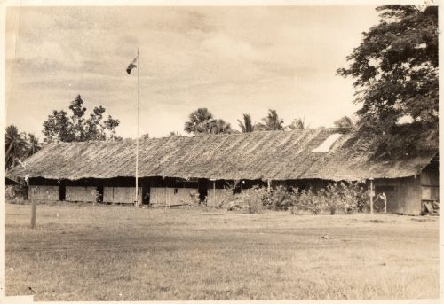The Northwestern Mindanao State College of Science and Technology (NMSC) started as Tangub Agro-Industrial School (TANAIS) in Sumirap, Tangub City way back in 1971 offering secondary agriculture and trade curricula with Mr. Jesus T. Bonilla as principal. On June 26, 1973, the school was transferred to Labuyo, Tangub City three kilometers from the city proper and approximately four hundred meters from the national highway, with Dr. Perfecto B. Yebes as the Vocational School Administrator. The school started offering post-secondary courses in 1974 and had been an affiliate off campus institute of the Central Mindanao University, Musuan, Bukidnon from 1979 to 1984. In 1994, Bachelor's Degree in Secondary Education and Industrial Technology were then offered. With the promotion of Dr. Yebes to a higher position, Mr. Apolonio S. Vidallo took place of the former and was appointed as the third administrator of TANAIS on August 6, 1996.

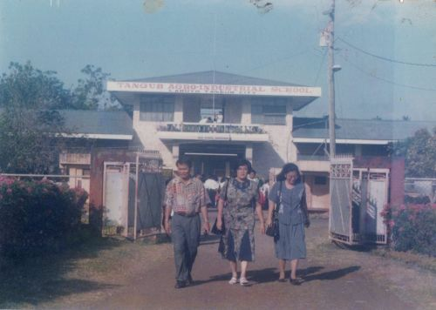Prior to Dr. Yebes' promotion, in 1992 he and Atty. Philip T. Tan, the City Myor of Tangub at that time, conceived the idea of converting TANAIS into a state college. The proposal was filed in Congress by the late Hon. Hilarion Ramiro Jr., the Congressman of the 2nd District of Misamis Occidental at that time. The bill was not passed due to adjournment or the 9th Congress in 1995. The bill to convert TANAIS into a State College was refilled in the 10th Congress in 1995 by Congresswoman Herminia M. Ramiro. The bill passed both houses but with a last-minute amendment to transfer the main campus from TANAIS in Tangub City to Oroquieta Agro-Industrial School (OAIS) at Oroquieta City.

Learning the amendment, Mayor Tan and Mr. Numeriano L. Gilbolingo and conferred with Congresswoman Herminia M. Ramiro to find the constitutional ground and had bill vetoed by President Fidel V. Ramos.

The bill was refiled in 1998 by the late Congressman Hilarion A. Ramiro Jr. It has already passed the lower house in 2000. By December 2000, Congressman Ramiro, Mayor Philip T. Tan, wife Jennifer Wee Tan and Mr. Numeriano L. Gilbolingo who represented Administrator Apolonio S. Vidallo successfully defended the conversion of Tangub Agro-Industrial School into Northwestern Mindanao State College of Science and Technology (NMSC) before the Senate Committee on Education chaired by the Honorable Sen. Teresita Aquino Oreta with the endorsement of Dr. Ester A. Garcia, Chairperson of the Commission on Higher Education.

Unfortunately, Congressman Ramiro died in January 2001. Congresswoman Herminia A. Ramiro was elected in May 2001, replacing the late Congressman Hilarion Ramiro Jr. With joint effort of Atty. Philip T. Tan and Congresswoman Herminia A. Ramiro, R.A. 9146 was finally approved by President Gloria Macapagal-Arroyo on July 30, 2001.

Dr. Zenaida G. Gersana was then designated by the Commission on Higher Education as the Officer-In-Charge and the Board of Trustees (BOT) was created to serve as its governing body.

On May 26, 2003, the Board of Trustees unanimously elected and appointed Atty. Philip T. Tan, CPA as the First President of NMSC after a two-month exhaustive selection process conducted by the Search Committee for Presidency (SCP). Dr. Glory S. Magdale, former Regional Director of the Commission on Higher Education, Region X, Cagayan de Oro City chaired the Search Committee for the Presidency.

During the Presidency of Atty. Tan, infrastructure projects flourished in the College. Among these are the twenty-classroom Academic Building, the Legarda Hall which is a laboratory building for students enrolled in Hospitality Management, Student Food Court, and renovated Administration Offices. The projects significantly improved the physical facilities of the College.

The College occupies a total of 29 hectares campus site traversed by the barangay road leading to Panguil Bay, an area rich in marine resources with vast potentials suitable for home and industrial uses.

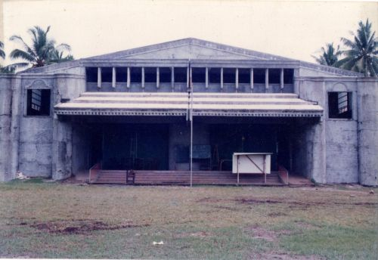

With the initiative of Atty. Philip Tan, the Php 5.4 million pesos financial assistance from the Department of Science and Technology for the upgrading of the Science laboratory of the College was finally approved.

Upon the resignation of Atty. Philip T. Tan as College President in order to head the call to go back to public service as Mayor of Tangub City, Dr. Ricardo E. Rotoras, the visionary and dynamic President of Mindanao University of Science and Technology (MUST) was designated by the Board of Trustees as Officer In-Charge of the College on March 2010 by virtue of BOT Resolution No. 03, s. 2010.

With the active and participative leadership of Dr. Rotoras, the College hurdled its share of challenges, and the second release of the DOST financial assistance was undertaken.

On September 6, 2012, Dr. Jennifer W. Tan was unanimously elected and appointed by the Board of Trustees as second President of the College by virtue of BOT Resolution No. 26, s. 2012.

With a strong advocacy on the culture of excellence, commendable and vast managerial expertise and networking competence of Dr. Tan, NMSC is never far from attaining is mandate of becoming a premier learning institution in the fields of education, agriculture, fishery, engineering, arts and sciences in Northwestern Mindanao.

## NMSCST VISION AND MISSION

**VISION**

An ecologically responsive University in Southern Philippines that fosters a culture of innovation and sustainability on the quality of lives in the community it serves.

CORE VALUES:

ASPIRE TO INSPIRE (AI)

**A** – ADAPTIVE

**S** – SELF-RELIANT

**P** – PRO-ACTIVE

**I** – INNOVATIVE

**R** – RESPONSIVE

**E** – EMPOWERING

**MISSION**

The University shall primarily provide advanced education, higher technological, professional instruction and training in the fields of agriculture, fisheries, engineering, information and communication technology, arts and sciences, education, business administration and management, health sciences and other relevant fields of study. It shall also undertake research, extension services and production activities in support of the socioeconomic development of the Province of Misamis Occidental and provide progressive leadership in its areas of specialization.

## SCHOOL SEAL

## SCHOOL HYMN

Northwestern Mindanao State College

Alma Mater dear we cling

Fly High radiant spirit

Your virtues we adhere

Northwestern Mindanao State College

We're proud to bear your name

Through the years your seal

Excels on high

The pride to you we bring

**Chorus:**

Northwestern Mindanao State College

All hail and praise to thee

With hope and love to you we bring

Oh, hear your children sing

Northwestern Mindanao State College

All hail... All hail... All hail

Molder of our hearts and minds to you our trust won't fail

**Bridge:**

Your guiding light we see

to God Almighty we revere

with faith and courage, we'll succeed

in unity we'll be free

**(Repeat Chorus:)**

Coda: To you our trust won't fail

## SCHOOL ORGANIZATIONAL CHART

## SCHOLARSHIP

As one of the primary services/units of the OSA, the program is manned by a Scholarship Coordinator. He/ She is in charge of disseminating information regarding available scholarships offered by the school, different government, non-government and private individuals/entities. He / She serves as a link between the scholarship provider and the students by preparing the necessary documents needed for the processing of the benefits/grants. The following are the scholarships available in NMSCST:

* Student Financial Assistance Program (StuFAP)
* Tertiary Education Subsidy (TES)
* Agricultural Competitiveness Enhancement Fund - Grants-In-Aid for Higher Education Program (ACEF-GIAHEP)
* Department of Science & Technology Scholarship
* School's Varsity and Performing Arts Scholarship
* Tangub City's Scholarship Program
* Private Scholarships
* Non-academic Institutional grants
* Entrance Scholarship

# NARRATIVE REPORT

## Week 1

|  |  |  |  |
| --- | --- | --- | --- |
| **DAY** | **DATE** | **DAILY ACCOMPLISHMENTS** | **NO. OF WORKING HOURS** |
| **Wednesday** | March 23, 2022 | Checking of MIS incomplete request report. | 4 Hours |
| **Thursday** | March 24, 2022 | Coding Math Accreditation Website | 8 Hours |
| **Friday** | March 25, 2022 | Continued coding Math Accreditation Website | 8 Hours |
| **Saturday** | March 26, 2022 | Overtime Coding Math Accreditation Website | 8 Hours |
| **Sunday** | March 27, 2022 | Overtime Coding Math Accreditation Website | 8 Hours |

**Total Number of Hours = 36 Hours**

## Week 2

|  |  |  |  |
| --- | --- | --- | --- |
| **DAY** | **DATE** | **DAILY ACCOMPLISHMENTS** | **NUMBER OF WORKING HOURS** |
| **Monday** | March 28, 2022 | 1st day Technical Support for Math Accreditation Zoom meeting. | 8 Hours |
| **Tuesday** | March 29, 2022 | 2nd day Technical Support for Math Accreditation Zoom meeting. | 8 Hours |
| **Wednesday** | March 30, 2022 | 3rd day Technical Support for Math Accreditation Zoom meeting. | 8 Hours |
| **Thursday** | March 31, 2022 | Installed “Any Desk” on school owned PC. | 8 Hours |
| **Friday** | April 1, 2022 | Technical Support for Math Accreditation Zoom meeting closing ceremony. | 8 Hours |

**Total Number of Hours = 40 Hours**

## Week 3

|  |  |  |  |
| --- | --- | --- | --- |
| **DAY** | **DATE** | **DAILY ACCOMPLISHMENTS** | **NUMBER OF WORKING HOURS** |
| **Monday** | April 4, 2022 | Continued installing “Any Desk” on school owned PC. | 8 Hours |
| **Tuesday** | April 5, 2022 | Continued installing “Any Desk” on school owned PC | 8 Hours |
| **Wednesday** | April 6, 2022 | Continued installing “Any Desk” on school owned PC | 8 Hours |
| **Thursday** | April 7, 2022 |  |  |
| **Friday** | April 8, 2022 | Installed Access Points. | 8 Hours |

**Total Number of Hours = 32 Hours**

## Week 4

|  |  |  |  |
| --- | --- | --- | --- |
| **DAY** | **DATE** | **DAILY ACCOMPLISHMENTS** | **NUMBER OF WORKING HOURS** |
| **Monday** | April 11, 2022 | Coding NMSCST Website. | 8 Hours |
| **Tuesday** | April 12, 2022 | Coding NMSCST Website. | 8 Hours |
| **Wednesday** | April 13, 2022 | Coding NMSCST Website. | 8 Hours |
| **Thursday** | April 14, 2022 | Coding NMSCST Website. | 8 Hours |
| **Friday** | April 15, 2022 | Coding NMSCST Website. | 8 Hours |
| **Monday** | April 11, 2022 | Coding NMSCST Website. | 8 Hours |
| **Tuesday** | April 12, 2022 | Coding NMSCST Website. | 8 Hours |

**Total Number of Hours = 40 Hours**

## Week 5

|  |  |  |  |
| --- | --- | --- | --- |
| **DAY** | **DATE** | **DAILY ACCOMPLISHMENTS** | **NUMBER OF WORKING HOURS** |
| **Monday** | April 18, 2022 | Coding Faculty Page NMSCST Website | 8 Hours |
| **Tuesday** | April 19, 2022 | Coding Faculty Page NMSCST Website | 8 hours |
| **Wednesday** | April 20, 2022 | Coding Faculty Page NMSCST Website | 8 hours |
| **Thursday** | April 21, 2022 | Coding Faculty Page NMSCST Website | 8 hours |
| **Friday** | April 22, 2022 | Coding Faculty Page NMSCST Website | 8 hours |
| **Monday** | April 18, 2022 | Coding Faculty Page NMSCST Website | 8 Hours |
| **Tuesday** | April 19, 2022 | Coding Faculty Page NMSCST Website | 8 hours |
| **Wednesday** | April 20, 2022 | Coding Faculty Page NMSCST Website | 8 hours |

**Total Number of Hours = 40 Hours**

## Week 6

|  |  |  |  |
| --- | --- | --- | --- |
| **DAY** | **DATE** | **DAILY ACCOMPLISHMENTS** | **NUMBER OF WORKING HOURS** |
| **Monday** | April 25, 2022 | Coding Faculty Page NMSCST Website | 8 Hours |
| **Tuesday** | April 26, 2022 | Coding Faculty Page NMSCST Website | 8 Hours |
| **Wednesday** | April 27, 2022 | Coding Faculty Page NMSCST Website | 8 Hours |
| **Thursday** | April 28, 2022 | Installed Internet PE Acad building. | 8 Hours |
| **Friday** | April 29, 2022 | Continue Coding Faculty Page NMSCST Website | 8 Hours |

**Total Number of Hours = 40 Hours**

## Week 7

|  |  |  |  |
| --- | --- | --- | --- |
| **DAY** | **DATE** | **DAILY ACCOMPLISHMENTS** | **NUMBER OF WORKING HOURS** |
| **Monday** | May 2, 2022 | Coding Lasalle School Website | 8 Hours |
| **Tuesday** | May 3, 2022 | Coding Lasalle School Website | 8 Hours |
| **Wednesday** | May 4, 2022 |  |  |
| **Thursday** | May 5, 2022 |  |  |
| **Friday** | May 6, 2022 | Coding Lasalle School Website | 8 Hours |

**Total Number of Hours = 24 Hours**

## Week 8

|  |  |  |  |
| --- | --- | --- | --- |
| **DAY** | **DATE** | **DAILY ACCOMPLISHMENTS** | **NUMBER OF WORKING HOURS** |
| **Monday** | May 9, 2022 | Coding Lasalle School Website | 8 Hours |
| **Tuesday** | May 10, 2022 | Coding Lasalle School Website | 8 Hours |
| **Wednesday** | May 11, 2022 | Coding Lasalle School Website | 8 Hours |
| **Thursday** | May 12, 2022 |  |  |
| **Friday** | May 13, 2022 | Coding Lasalle School Website | 8 Hours |

**Total Number of Hours = 32 Hours**

## Week 9

|  |  |  |  |
| --- | --- | --- | --- |
| **DAY** | **DATE** | **DAILY ACCOMPLISHMENTS** | **NUMBER OF WORKING HOURS** |
| **Monday** | May 16, 2022 | Coding Lasalle School Website | 8 Hours |
| **Tuesday** | May 17, 2022 | Coding Lasalle School Website | 8 Hours |
| **Wednesday** | May 18, 2022 |  |  |
| **Thursday** | May 19, 2022 | Coding Lasalle School Website | 8 Hours |
| **Friday** | May 20, 2022 |  |  |

**Total Number of Hours = 24 Hours**

## Week 10

|  |  |  |  |
| --- | --- | --- | --- |
| **DAY** | **DATE** | **DAILY ACCOMPLISHMENTS** | **NUMBER OF WORKING HOURS** |
| **Monday** | May 23, 2022 | Coding Lasalle School Website | 8 Hours |
| **Tuesday** | May 24, 2022 | Coding Lasalle School Website | 8 Hours |
| **Wednesday** | May 25, 2022 |  |  |
| **Thursday** | May 26, 2022 | Coding Lasalle School Website | 8 Hours |
| **Friday** | May 27, 2022 |  |  |

**Total Number of Hours = 24 Hours**

## Week 11

|  |  |  |  |
| --- | --- | --- | --- |
| **DAY** | **DATE** | **DAILY ACCOMPLISHMENTS** | **NUMBER OF WORKING HOURS** |
| **Monday** | May 30, 2022 | Coding Lasalle School Website | 8 Hours |
| **Tuesday** | May 31, 2022 | Coding Lasalle School Website | 8 Hours |
| **Wednesday** | June 1, 2022 | Coding Lasalle School Website | 8 Hours |
| **Thursday** | June 2, 2022 | Coding Lasalle School Website | 8 Hours |
| **Friday** | June 3, 2022 | Coding Lasalle School Website | 8 Hours |

**Total Number of Hours = 40 Hours**

## Week 12

|  |  |  |  |
| --- | --- | --- | --- |
| **DAY** | **DATE** | **DAILY ACCOMPLISHMENTS** | **NUMBER OF WORKING HOURS** |
| **Monday** | June 6, 2022 | Coding Lasalle School Website | 8 Hours |
| **Tuesday** | June 7, 2022 | Coding Lasalle School Website | 8 Hours |
| **Wednesday** | June 8, 2022 | Coding Lasalle School Website | 8 Hours |
| **Thursday** | June 9, 2022 | Coding Lasalle School Website | 8 Hours |
| **Friday** | June 10, 2022 | Coding Lasalle School Website | 8 Hours |

**Total Number of Hours = 40 Hours**

## Week 13

|  |  |  |  |
| --- | --- | --- | --- |
| **DAY** | **DATE** | **DAILY ACCOMPLISHMENTS** | **NUMBER OF WORKING HOURS** |
| **Monday** | June 13, 2022 | Coding Lasalle School Website | 8 Hours |
| **Tuesday** | June 14, 2022 | Coding Lasalle School Website | 8 Hours |
| **Wednesday** | June 15, 2022 | Coding Lasalle School Website | 8 Hours |
| **Thursday** | June 16, 2022 | Coding Lasalle School Website | 8 Hours |
| **Friday** | June 17, 2022 | Coding Lasalle School Website | 8 Hours |

**Total Number of Hours = 40 Hours**

## Week 14

|  |  |  |  |
| --- | --- | --- | --- |
| **DAY** | **DATE** | **DAILY ACCOMPLISHMENTS** | **NUMBER OF WORKING HOURS** |
| **Monday** | June 20, 2022 |  |  |
| **Tuesday** | June 21, 2022 |  |  |
| **Wednesday** | June 22, 2022 | Coding Lasalle School Website | 8 Hours |
| **Thursday** | June 23, 2022 |  |  |
| **Friday** | June 24, 2022 | Coding Lasalle School Website | 8 Hours |

**Total Number of Hours = 16 Hours**

## Week 15

|  |  |  |  |
| --- | --- | --- | --- |
| **DAY** | **DATE** | **DAILY ACCOMPLISHMENTS** | **NUMBER OF WORKING HOURS** |
| **Monday** | June 27, 2022 | Coding Lasalle School Website | 8 Hours |
| **Tuesday** | June 28, 2022 | Coding Lasalle School Website | 8 Hours |
| **Wednesday** | June 29, 2022 |  |  |
| **Thursday** | June 30, 2022 | Coding Lasalle School Website | 8 Hours |
| **Monday** | June 27, 2022 | Coding Lasalle School Website | 8 Hours |

**Total Number of Hours = 24 Hours**

# LEARNINGS

The Northwestern Mindanao State College of Science and Technology MIS Office has been a great help to me as an OJT trainee. They have taught me fresh information that I can use to expand my expertise. I discovered a great deal more throughout my stay there, which was worthwhile. I can use these lessons I've learned to be productive at my new job and to pass on my knowledge to those around me. It aided in my professional growth and helped me to love my job and the people I met for the first time.

# CONCLUSION

One of the most memorable college experiences for every student was serving as an OJT for more than 486 hours. It aided me in developing my knowledge and abilities. I acquired fresh knowledge that I did not previously possess. Working with professionals has given me the confidence to conduct myself professionally. This OJT program also helped me develop self-discipline by adhering to workplace ethics, such as arriving at work on time. Both I and my fellow trainees will benefit from this training. It gave us the chance to learn more skills and methods for carrying out different jobs and duties.

# APPENDICES

## EVALUATION SHEET

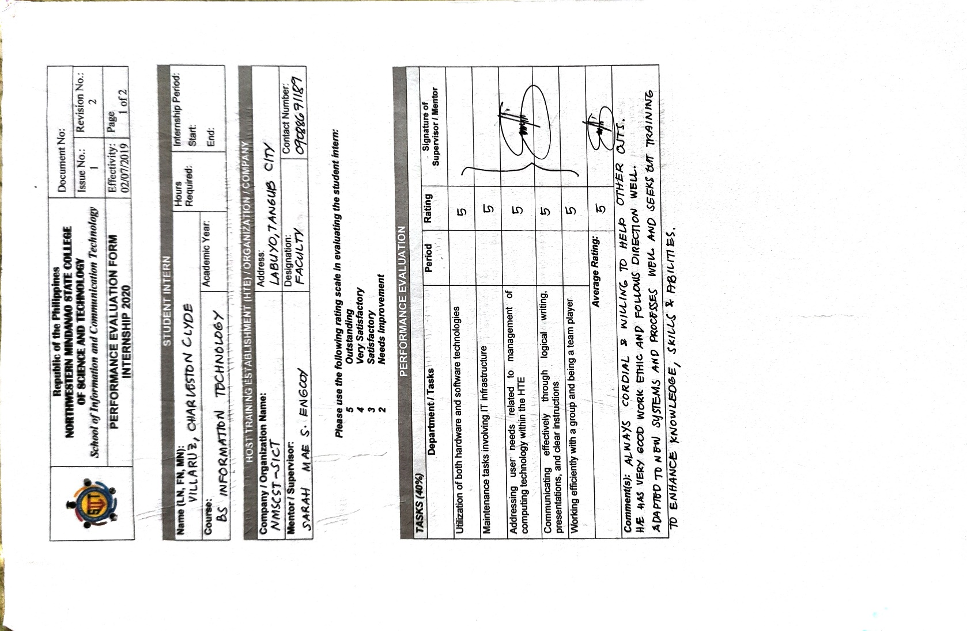

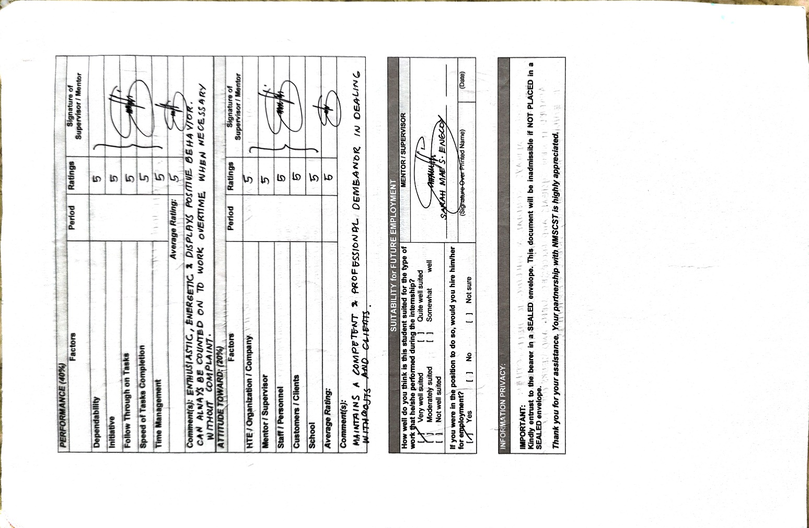

## CERTIFICATE OF COMPLETION

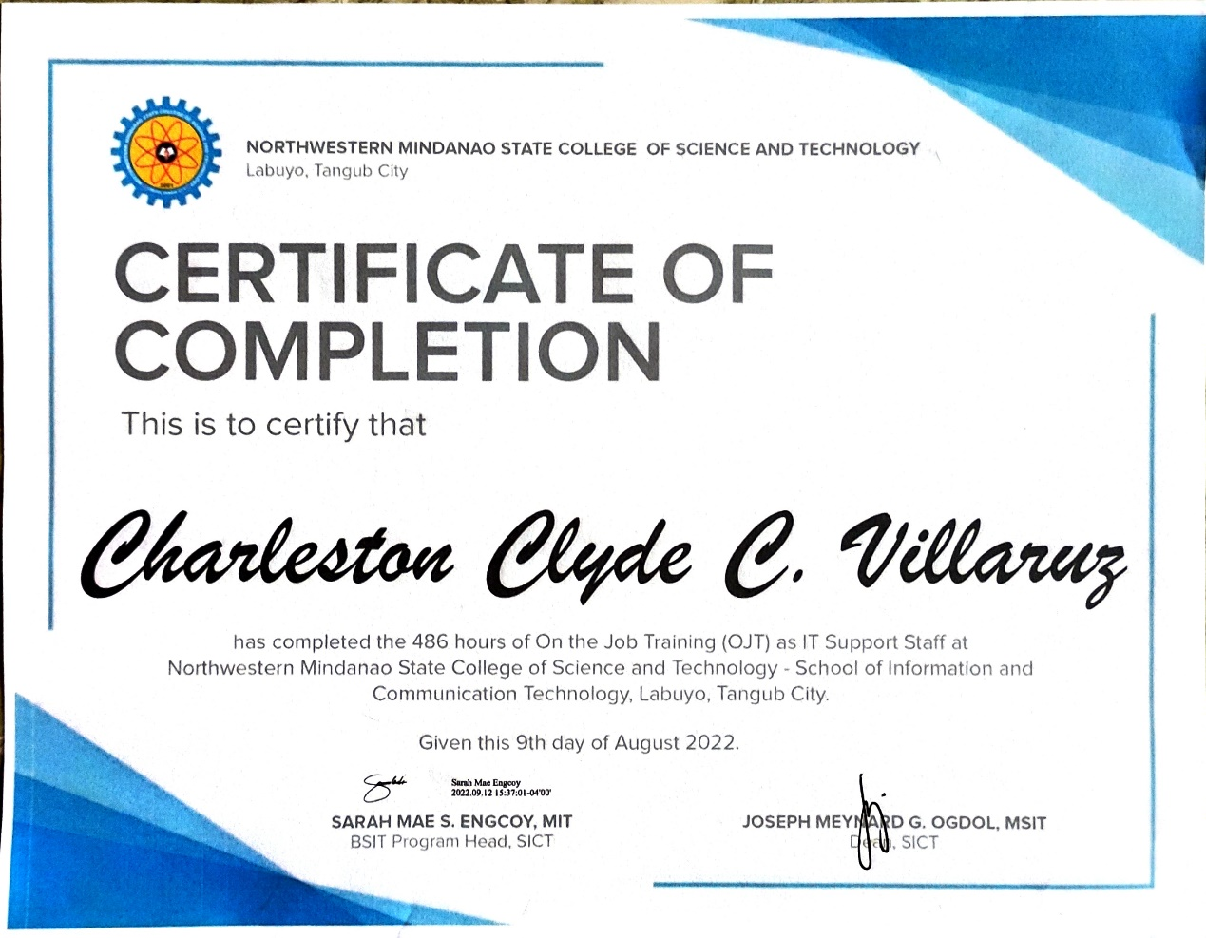

## SUMMARY OF HOURS

|  |  |
| --- | --- |
| **NUMBER OF WEEKS** | **TOTAL NUMBER OF HOURS** |
| **WEEK 1** - March, 23 – 27, 2022 | 36 |
| **WEEK 2** - March 28 - April 1, 2022 | 40 |
| **WEEK 3** - April 4 -8, 2022 | 32 |
| **WEEK 4** - April 11 – 15, 2022 | 40 |
| **WEEK 5** - April 18 – 22, 2022 | 40 |
| **WEEK 6** - May 25 – 29, 2022 | 40 |
| **WEEK 7** - May 2 – 6, 2022 | 24 |
| **WEEK 8** - May 9 – 13, 2022 | 32 |
| **WEEK 9** - May 16 – 19, 2022 | 24 |
| **WEEK 10 -** May 23 – 26, 2022 | 24 |
| **WEEK 11** - May 30 - June 3, 2022 | 40 |
| **WEEK 12** - June 6 – 10, 2022 | 40 |
| **WEEK 13** - June 13 – 17, 2022 | 40 |
| **WEEK 14** - June 22 - 24, 2022 | 16 |
| **WEEK 15** - June 27 – 30, 2022 | 24 |

**TOTAL HOURS = 492 Hours**

## DAILY TIME RECORD

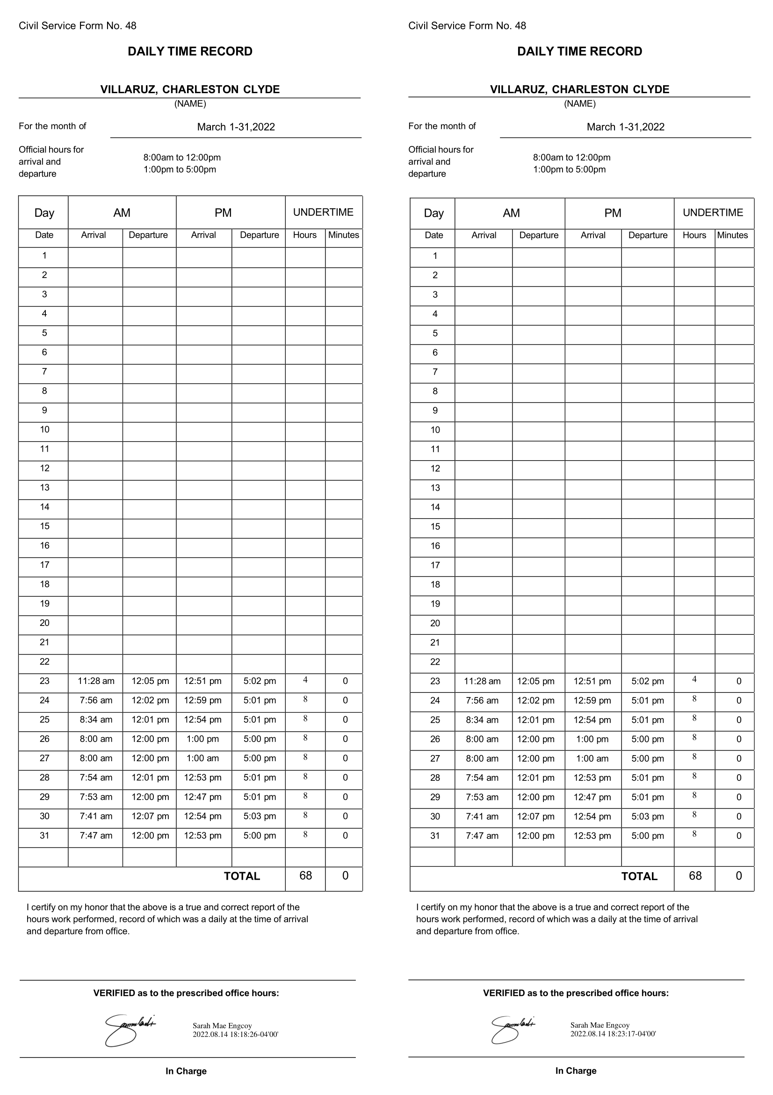

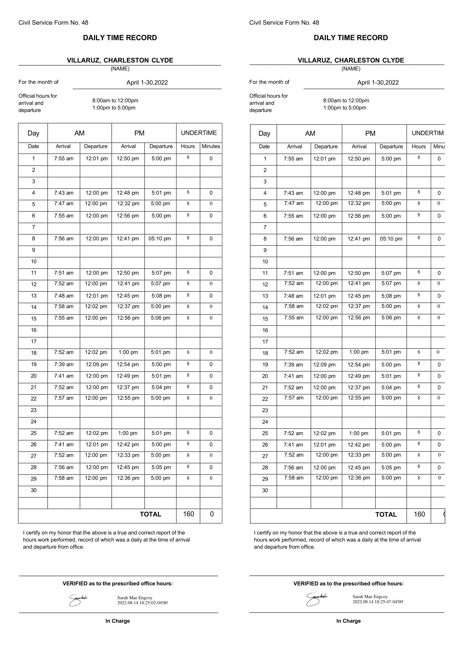

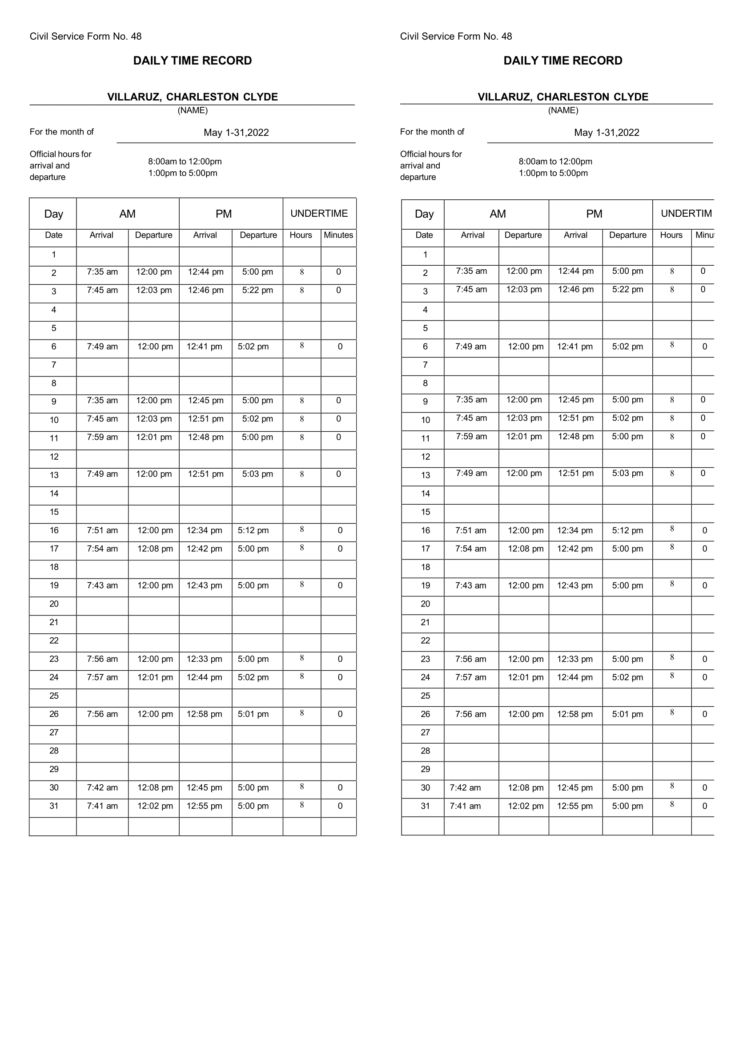

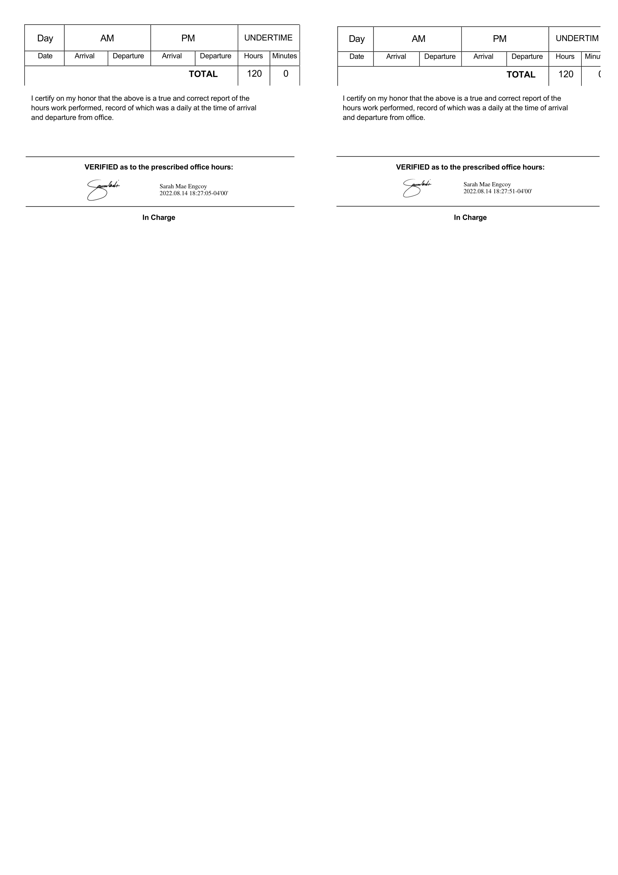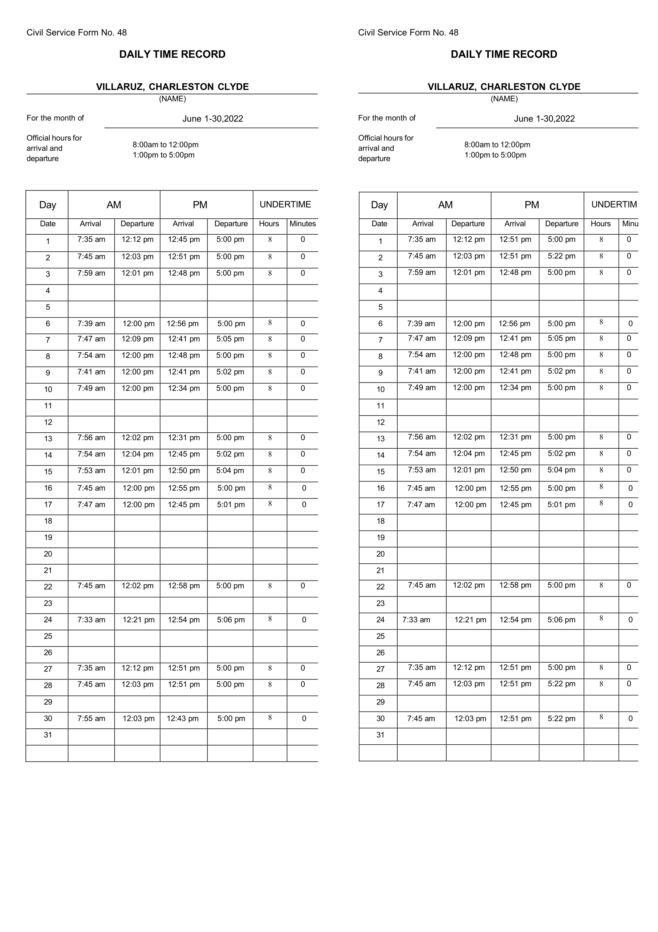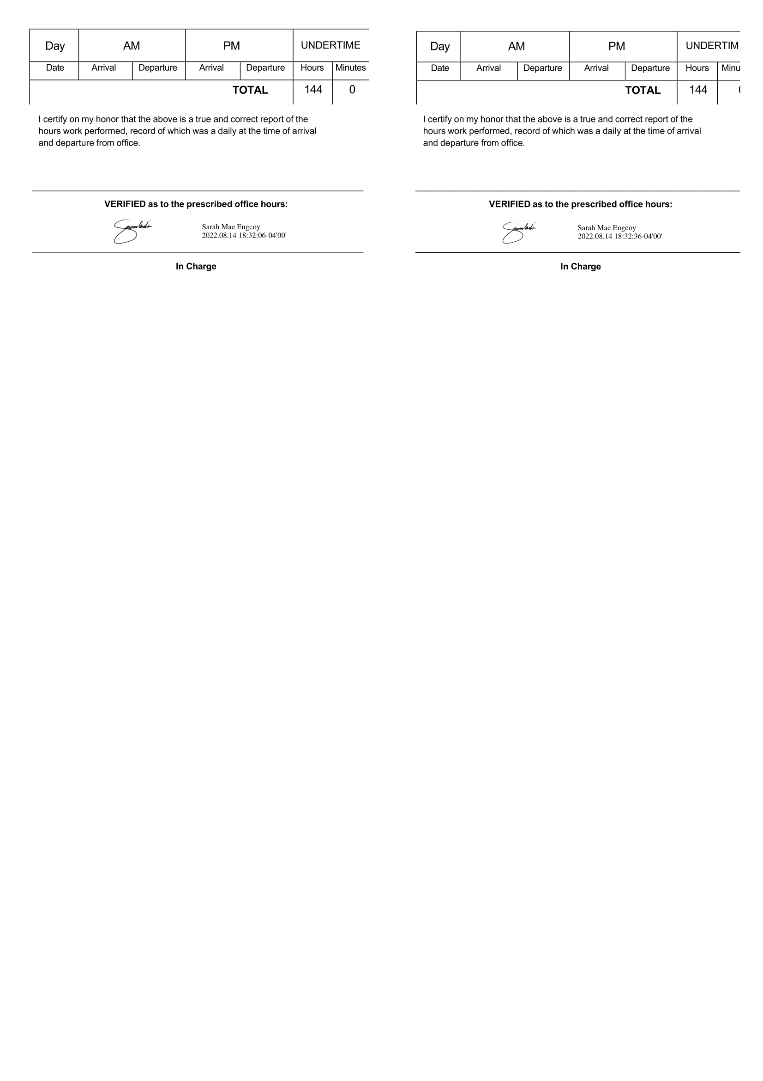

## WRITTEN CONSENT



## LETTER OF ACCEPTANCE

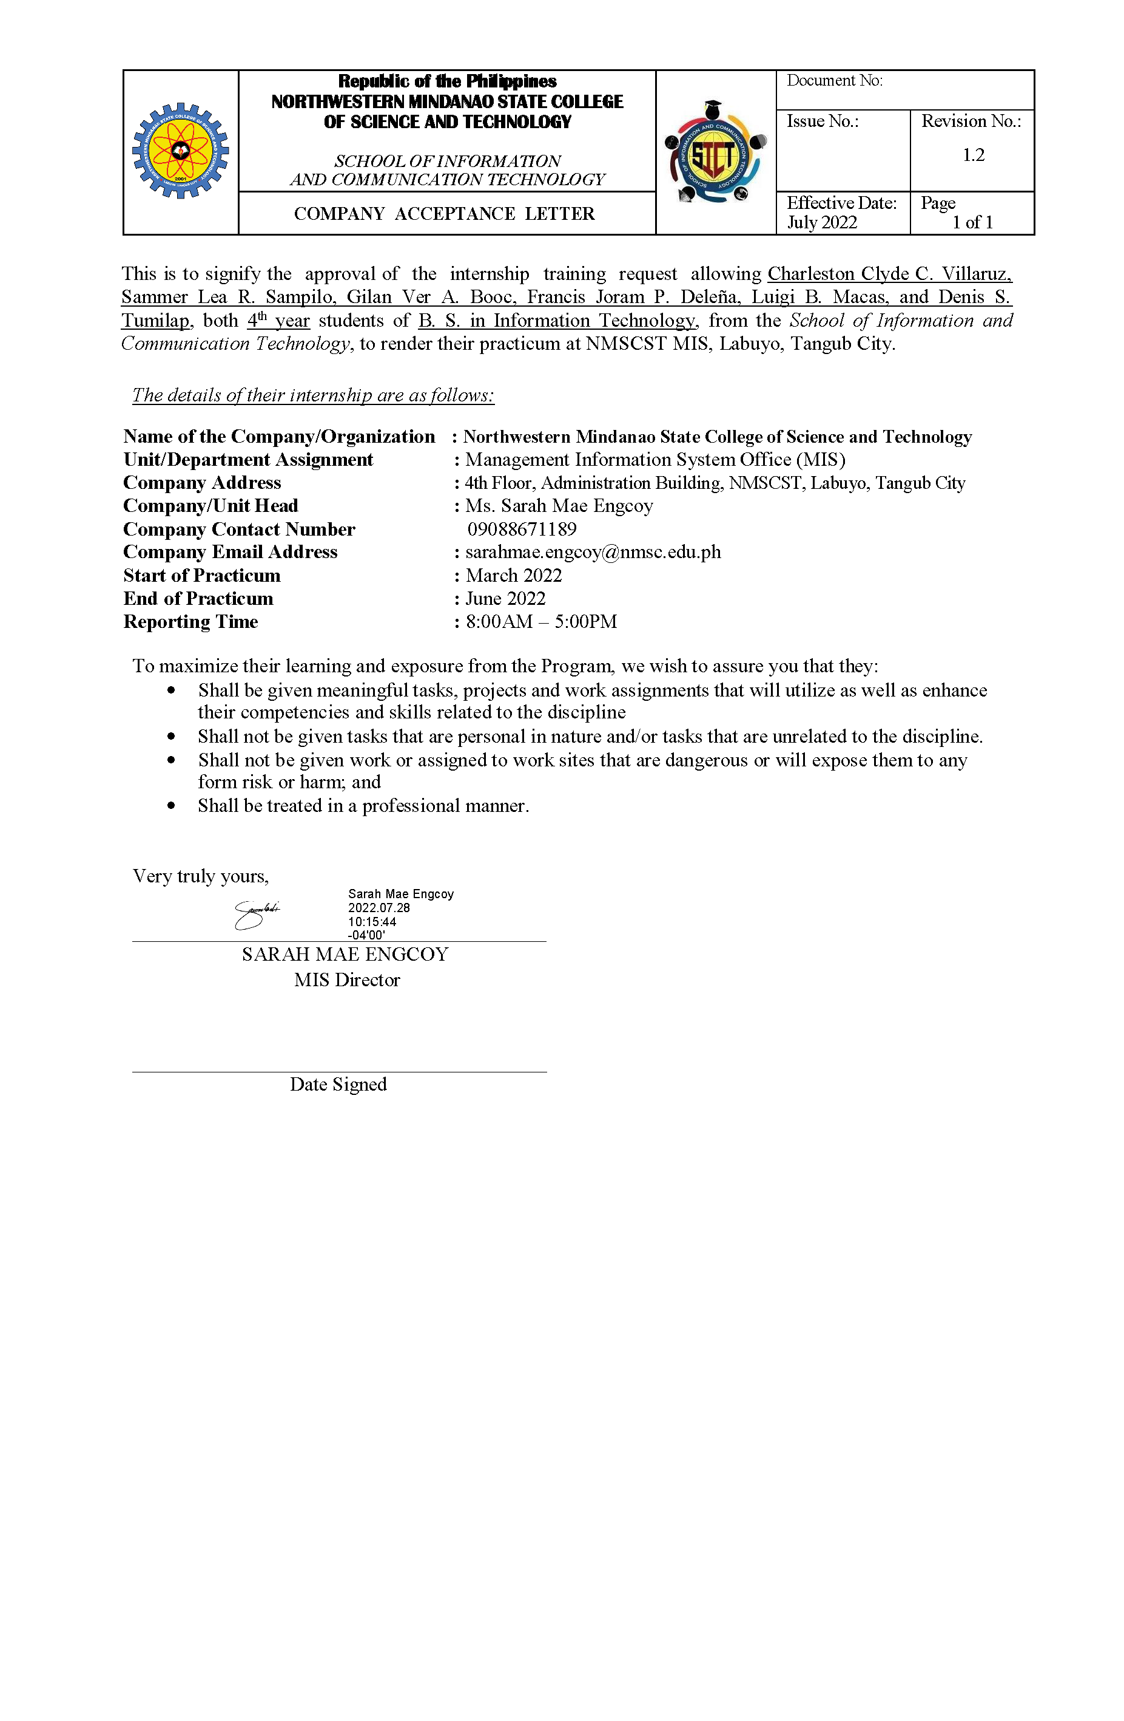

## 

## MEMORANDUM OF AGREEMENT

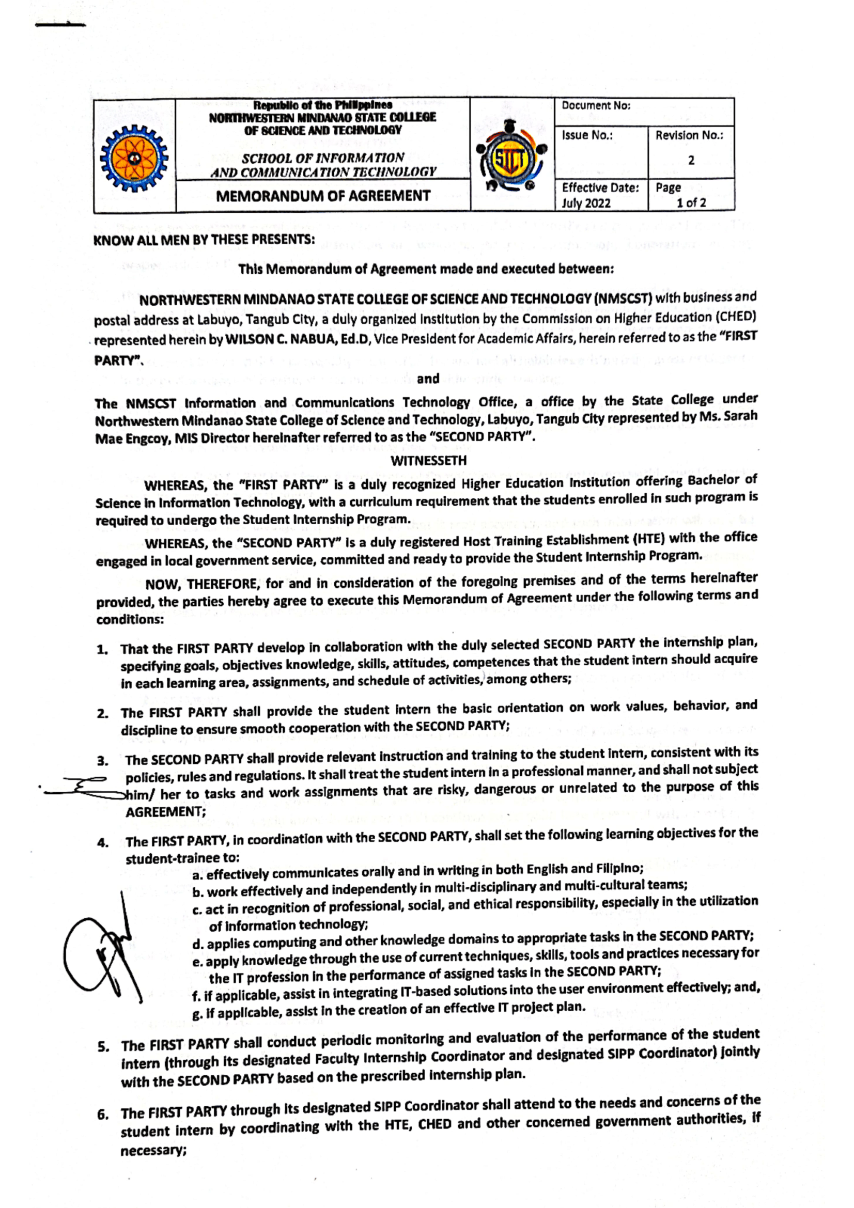

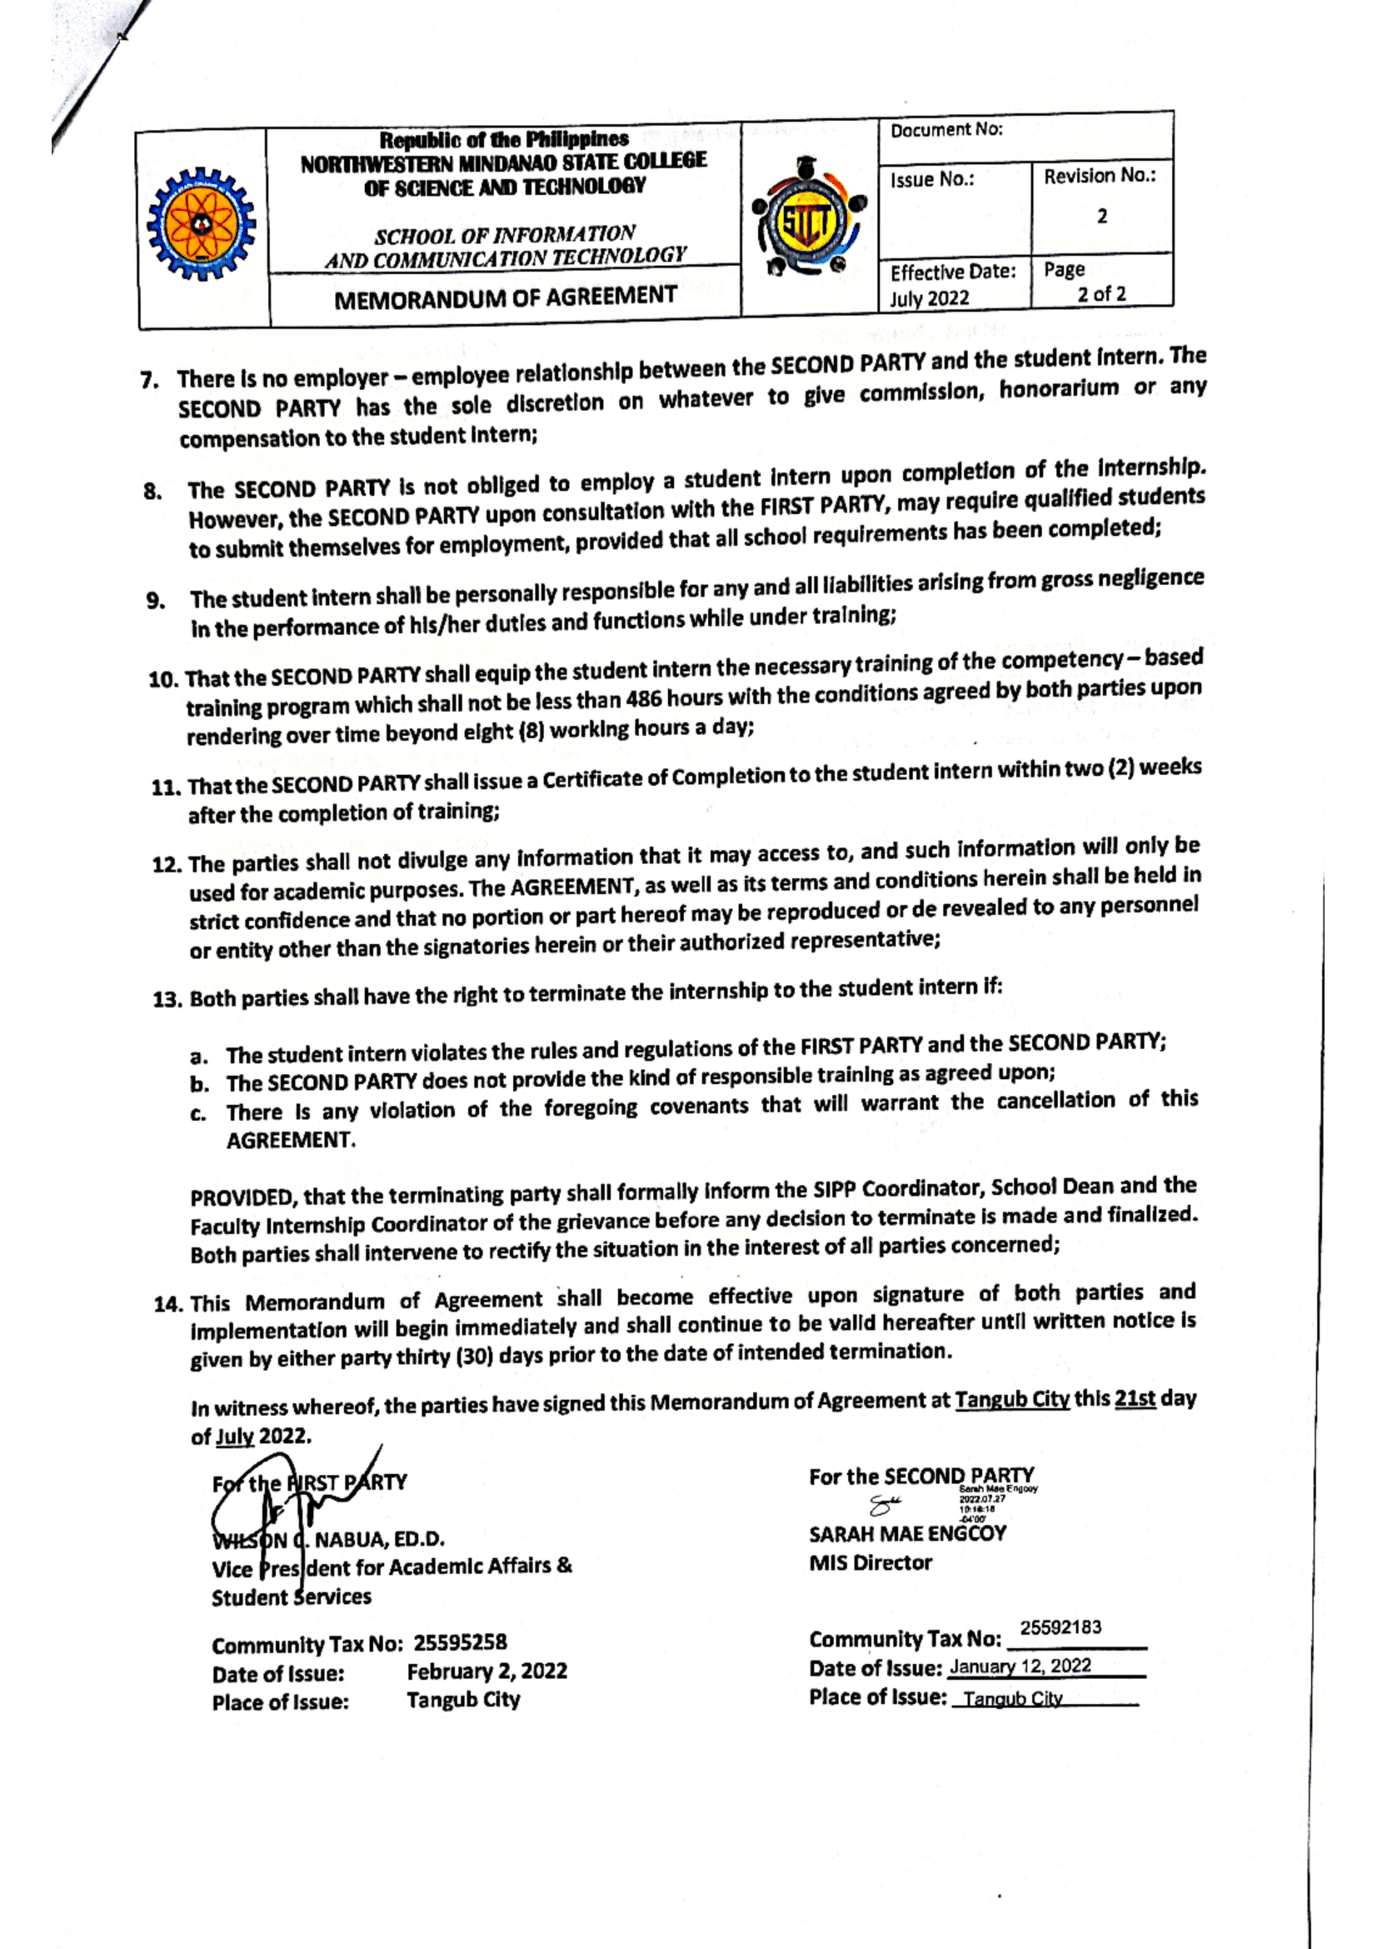

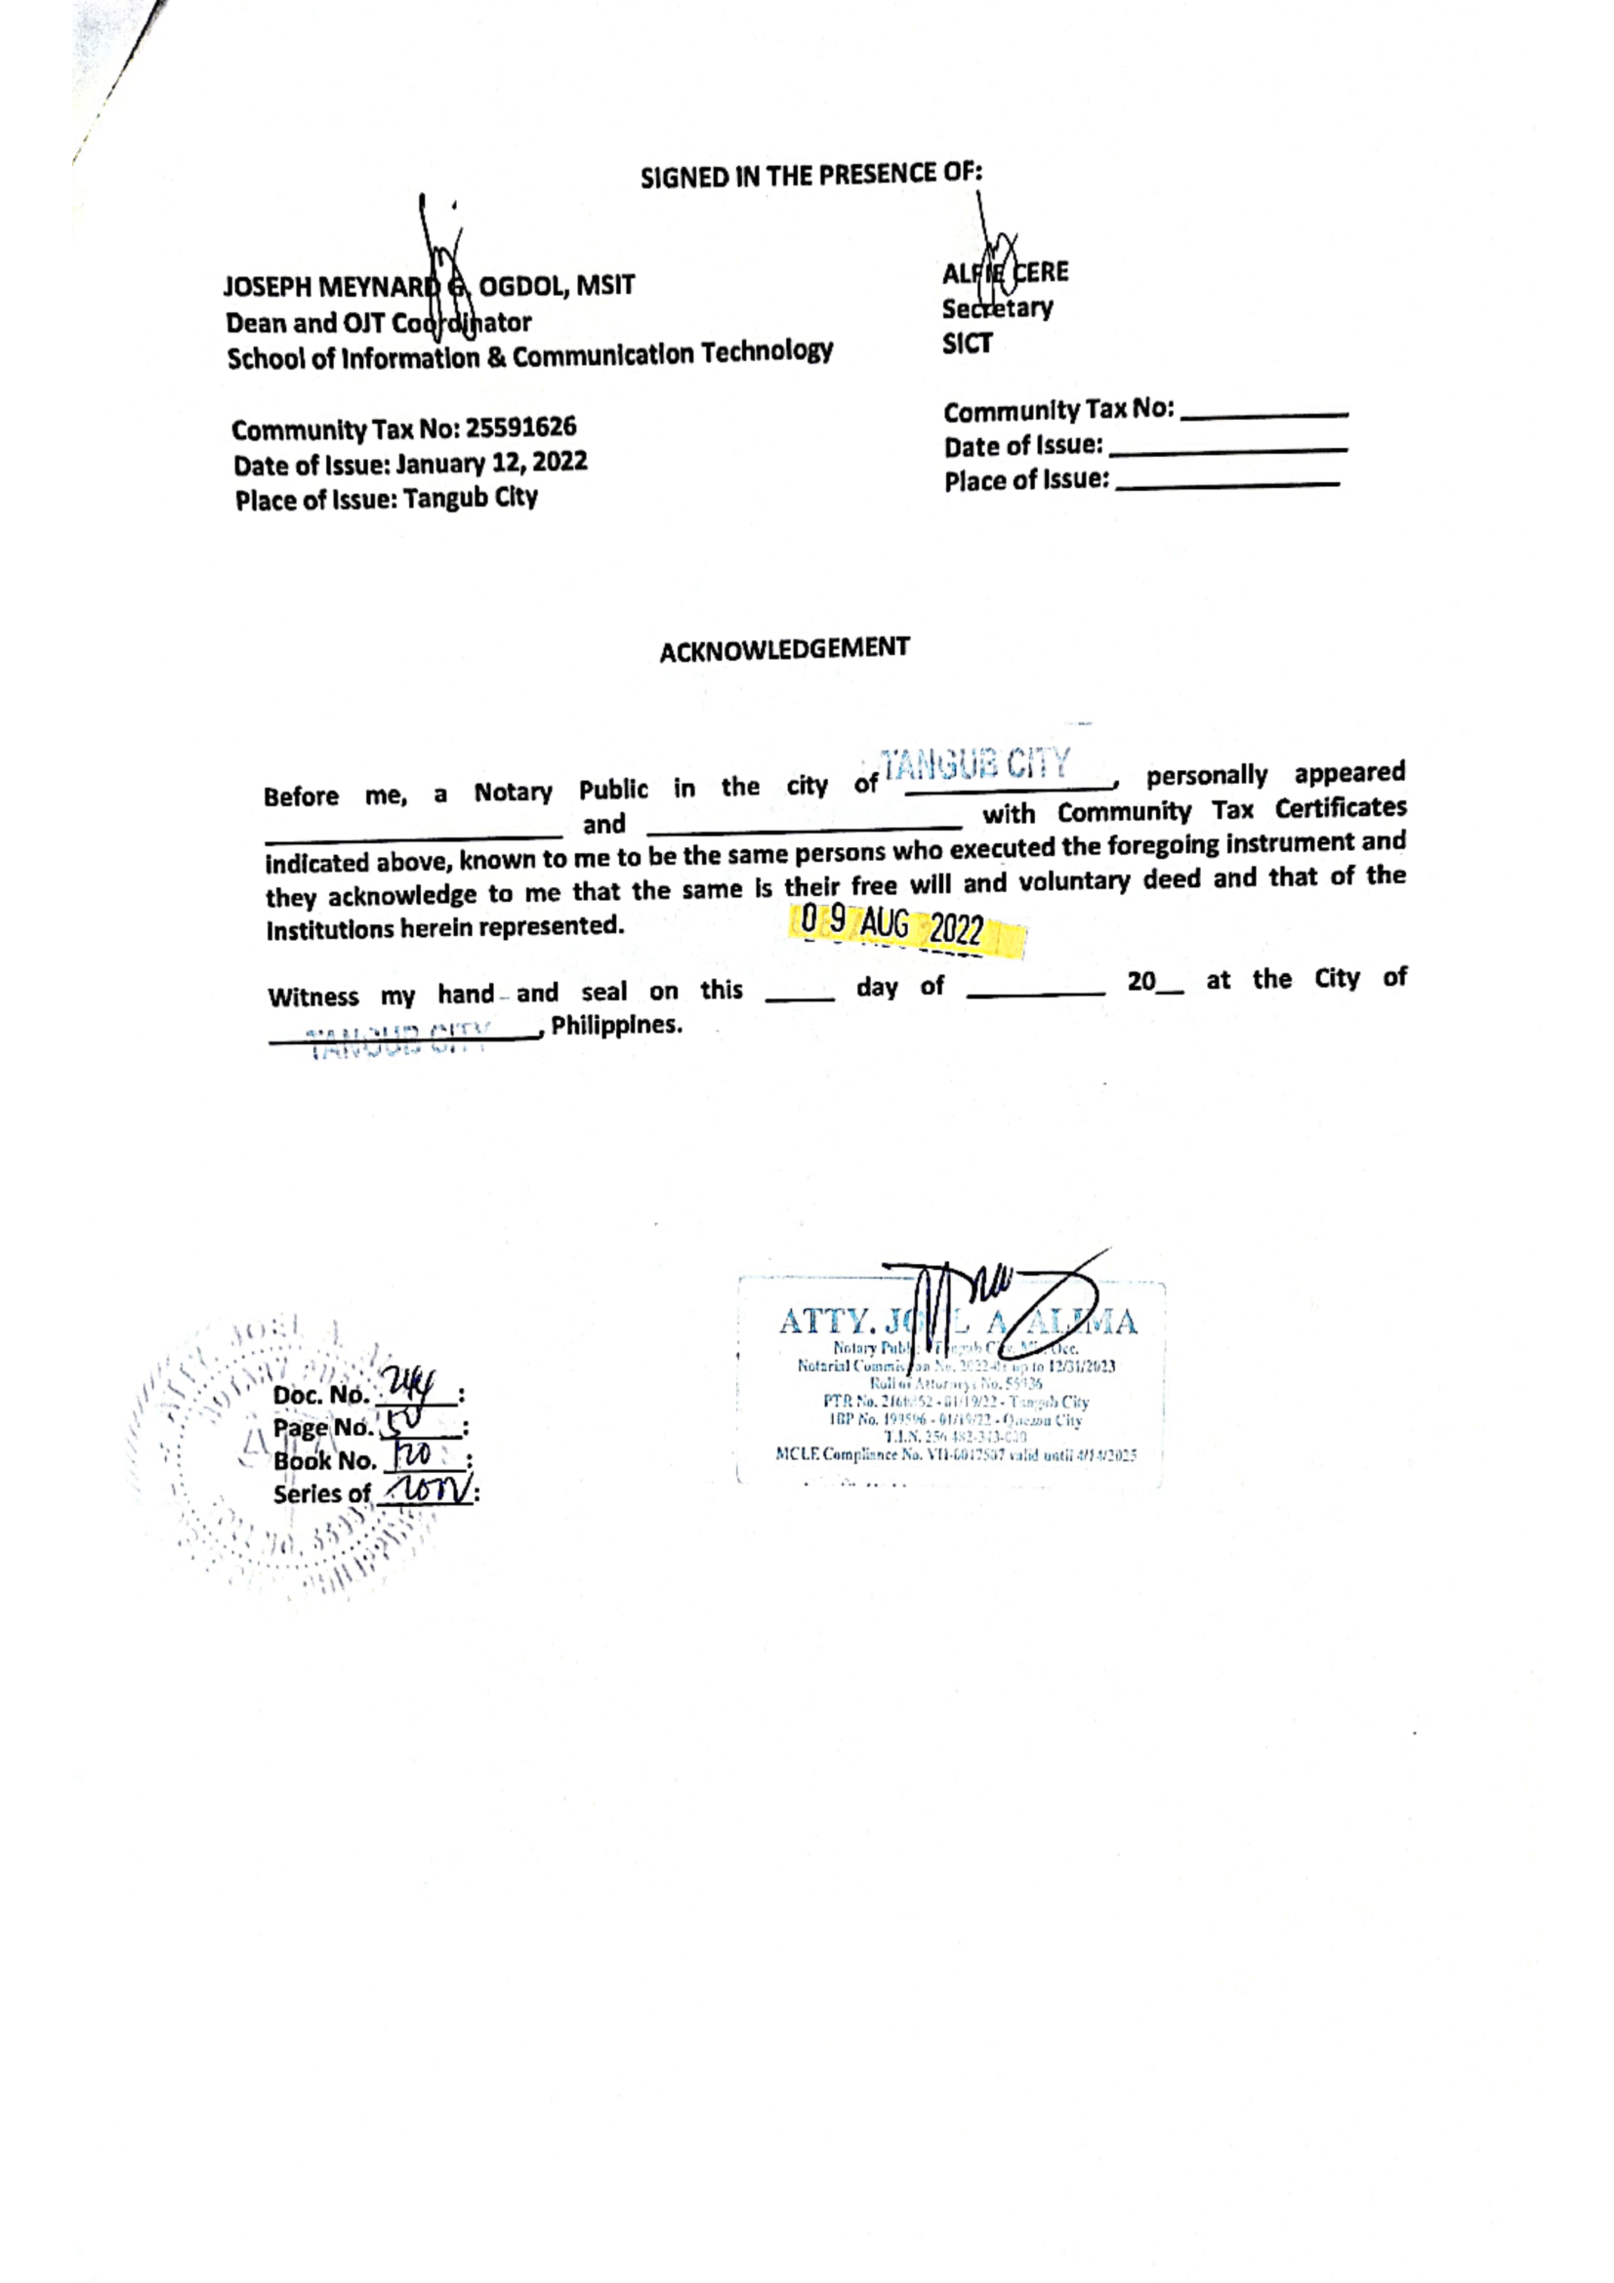

## MEDICAL CERTIFICATE

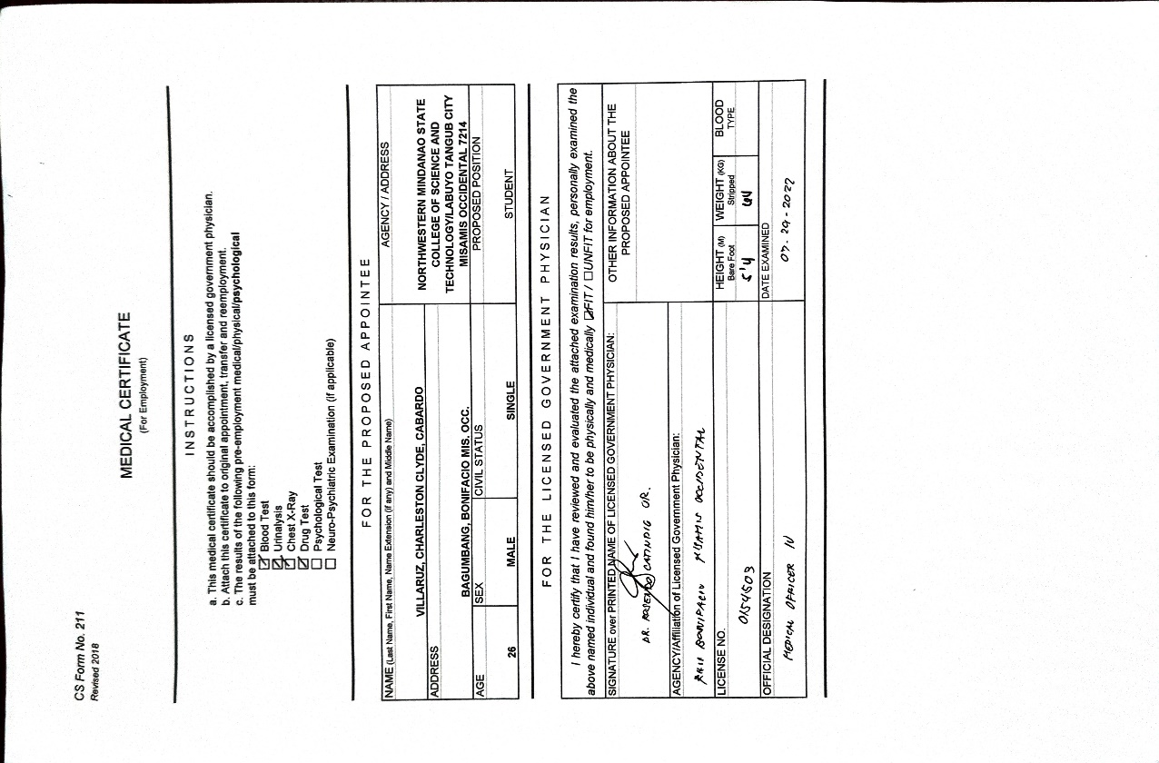

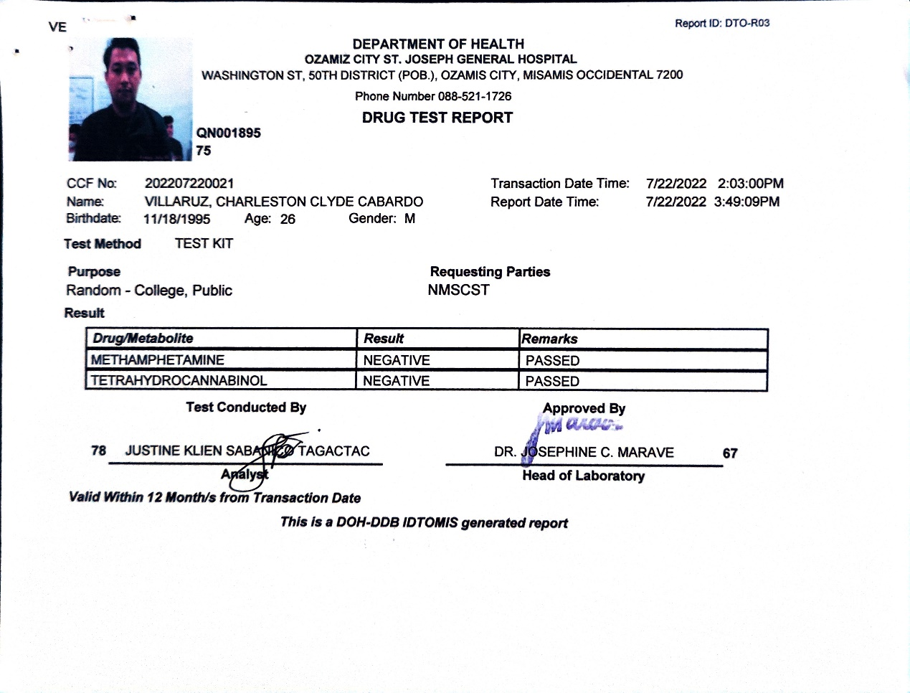



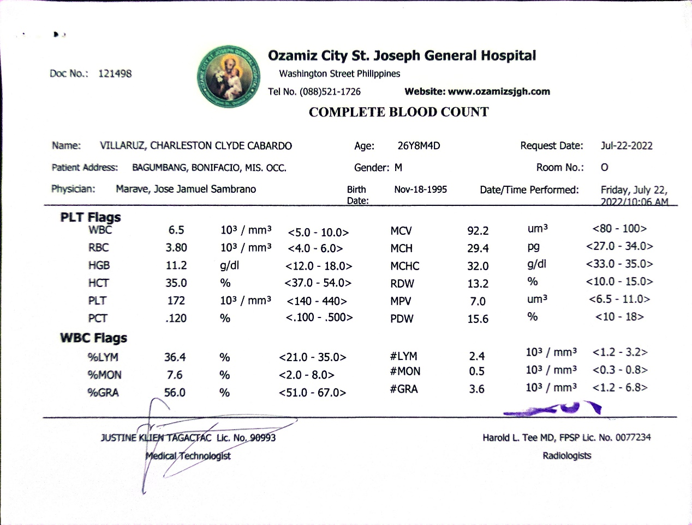

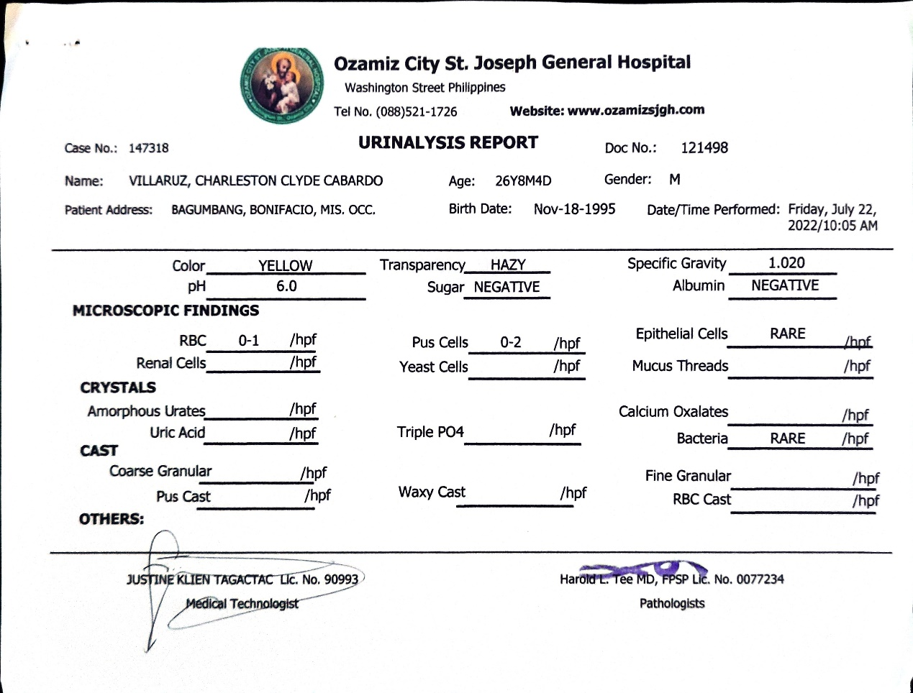

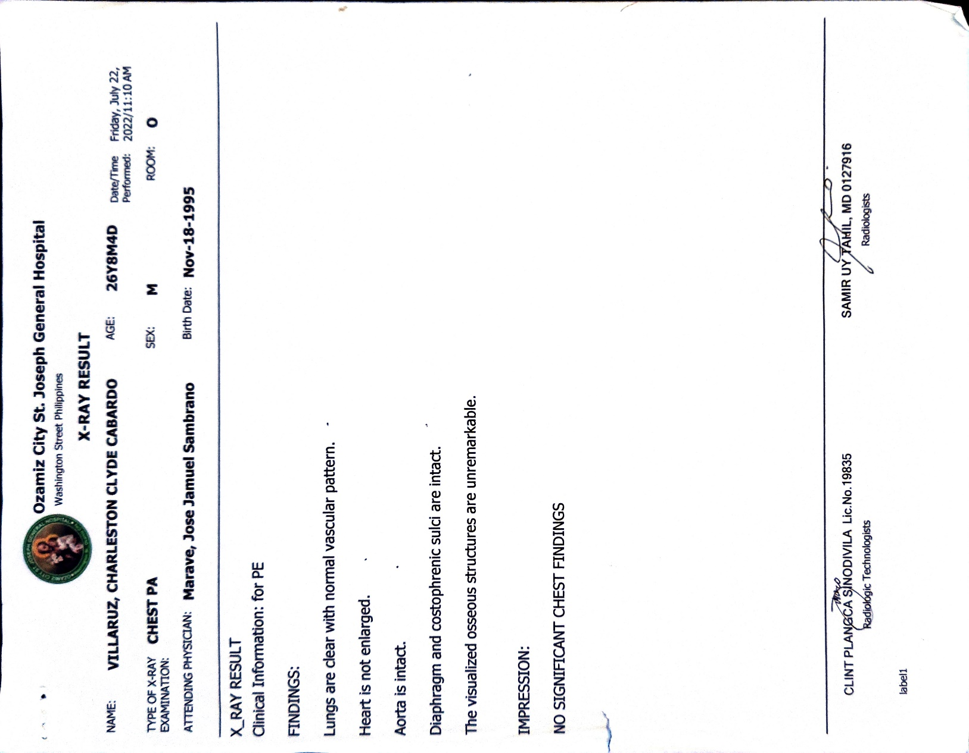

## DOCUMENTATION

Computer assembly in the new Mathematics Laboratory.

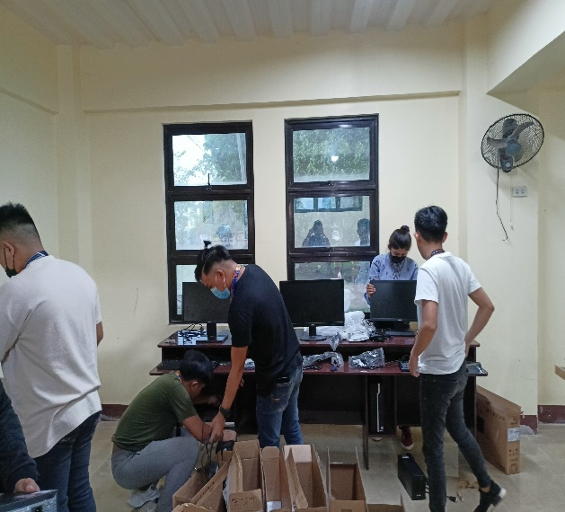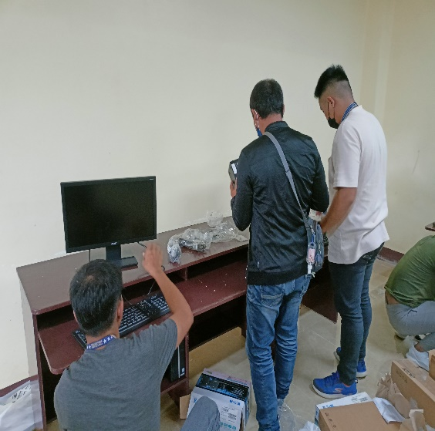

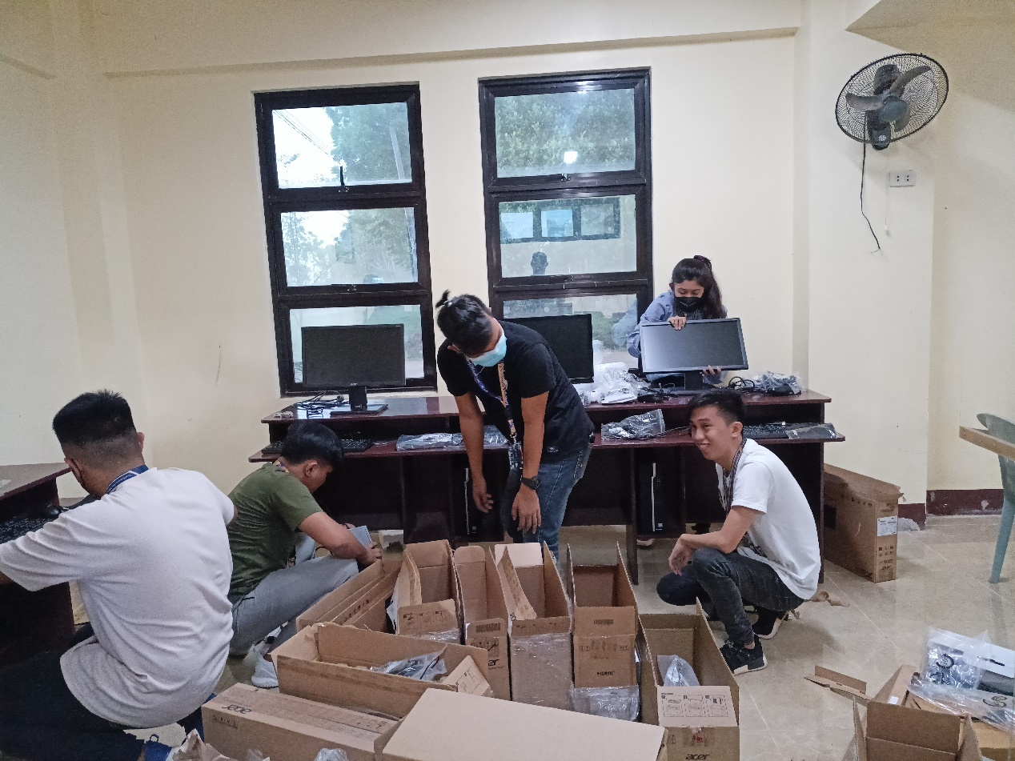

Setting up internet for Pe Academic Building.

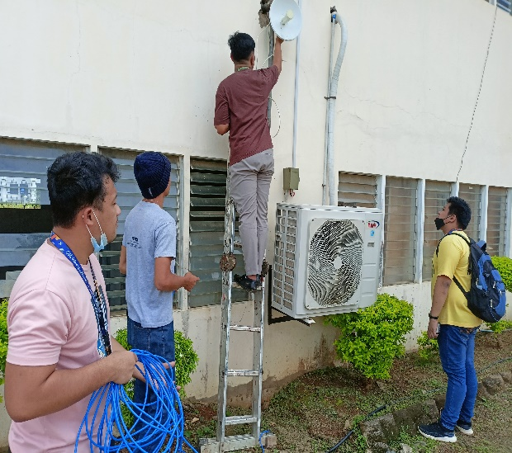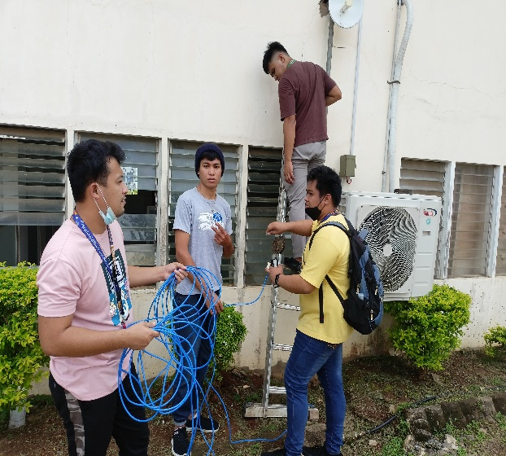

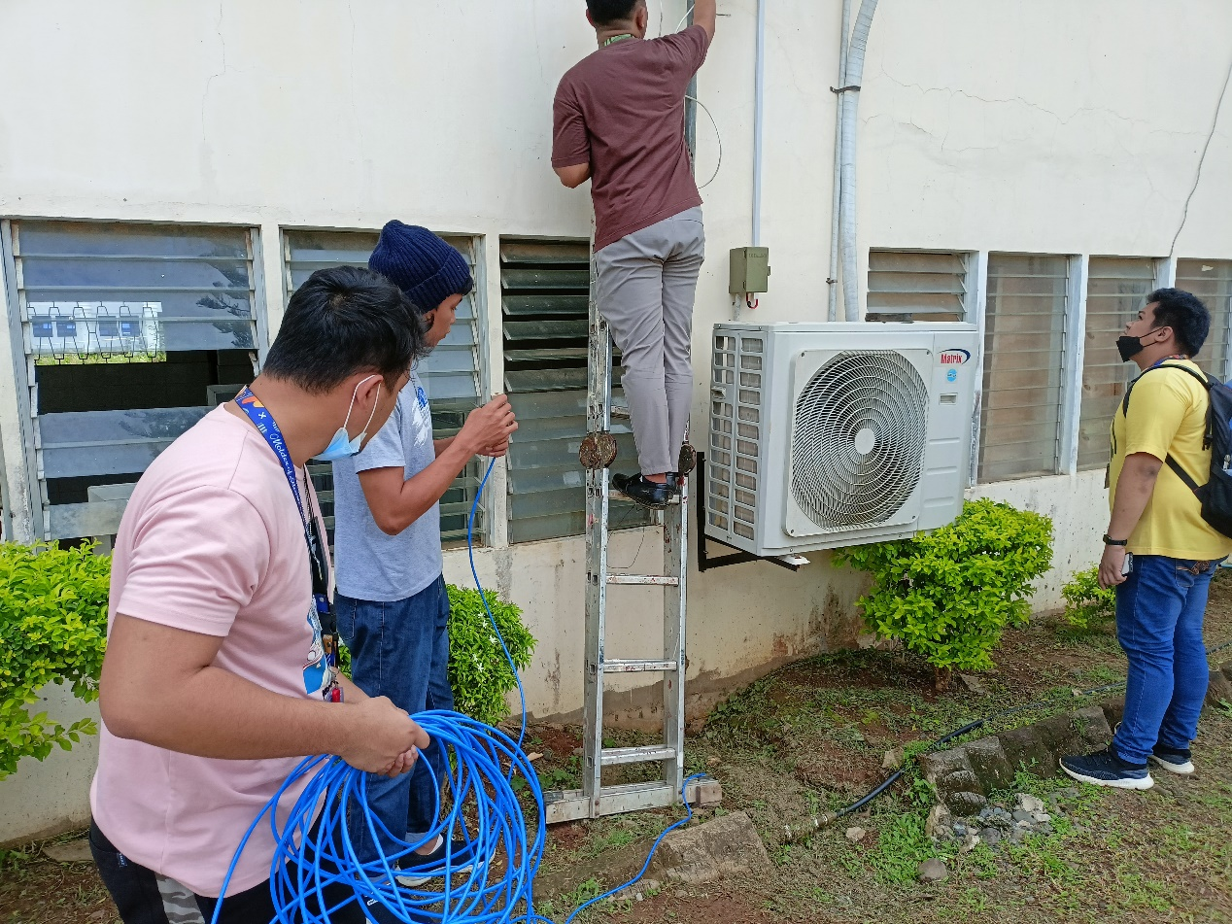

Coding some modifications for the NMSCST website.

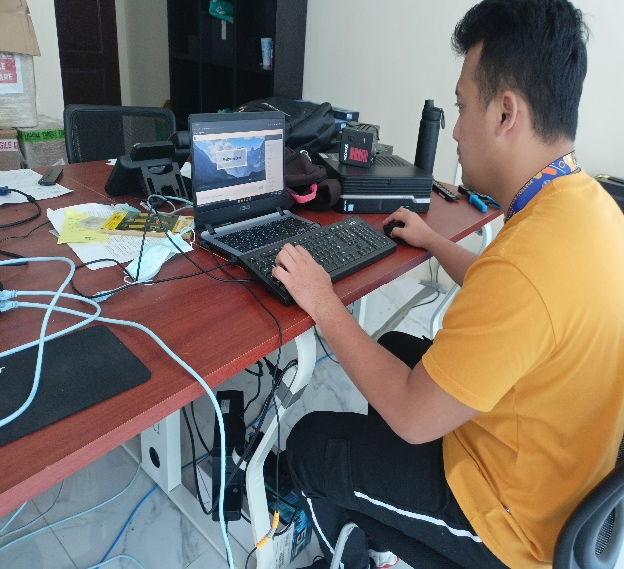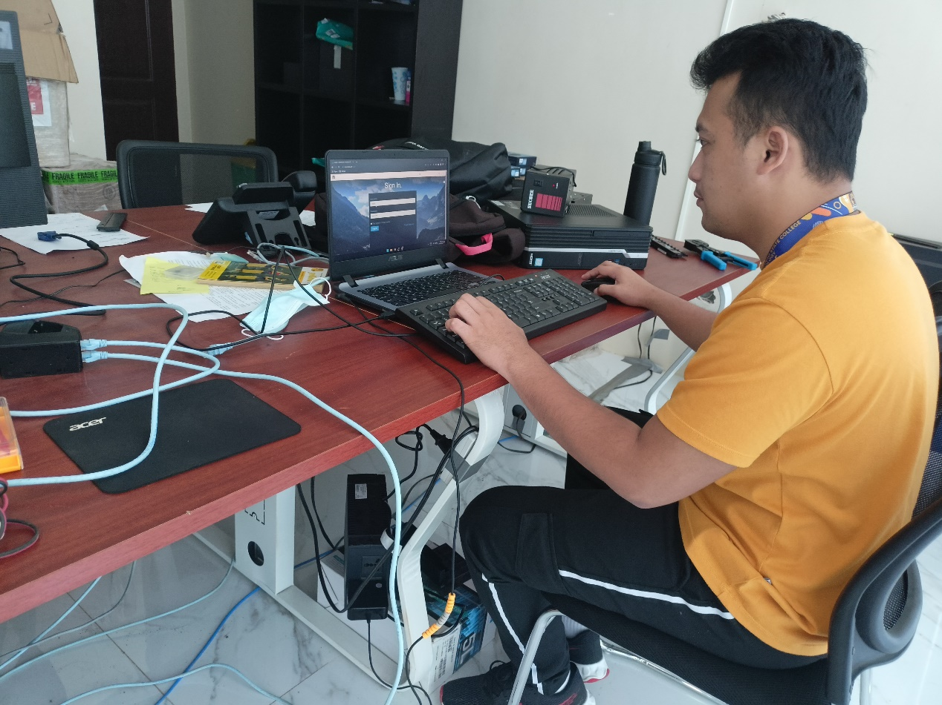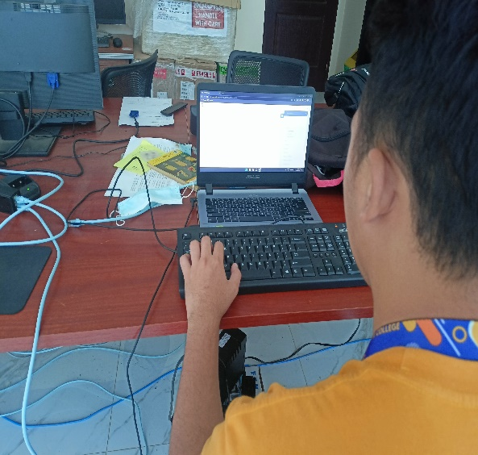

## RESUME

